User Manual of MPPT Solar Charge Controller
20A\30A\40A\50A\60A

Maximum PV(voc) Voltage: DC150V

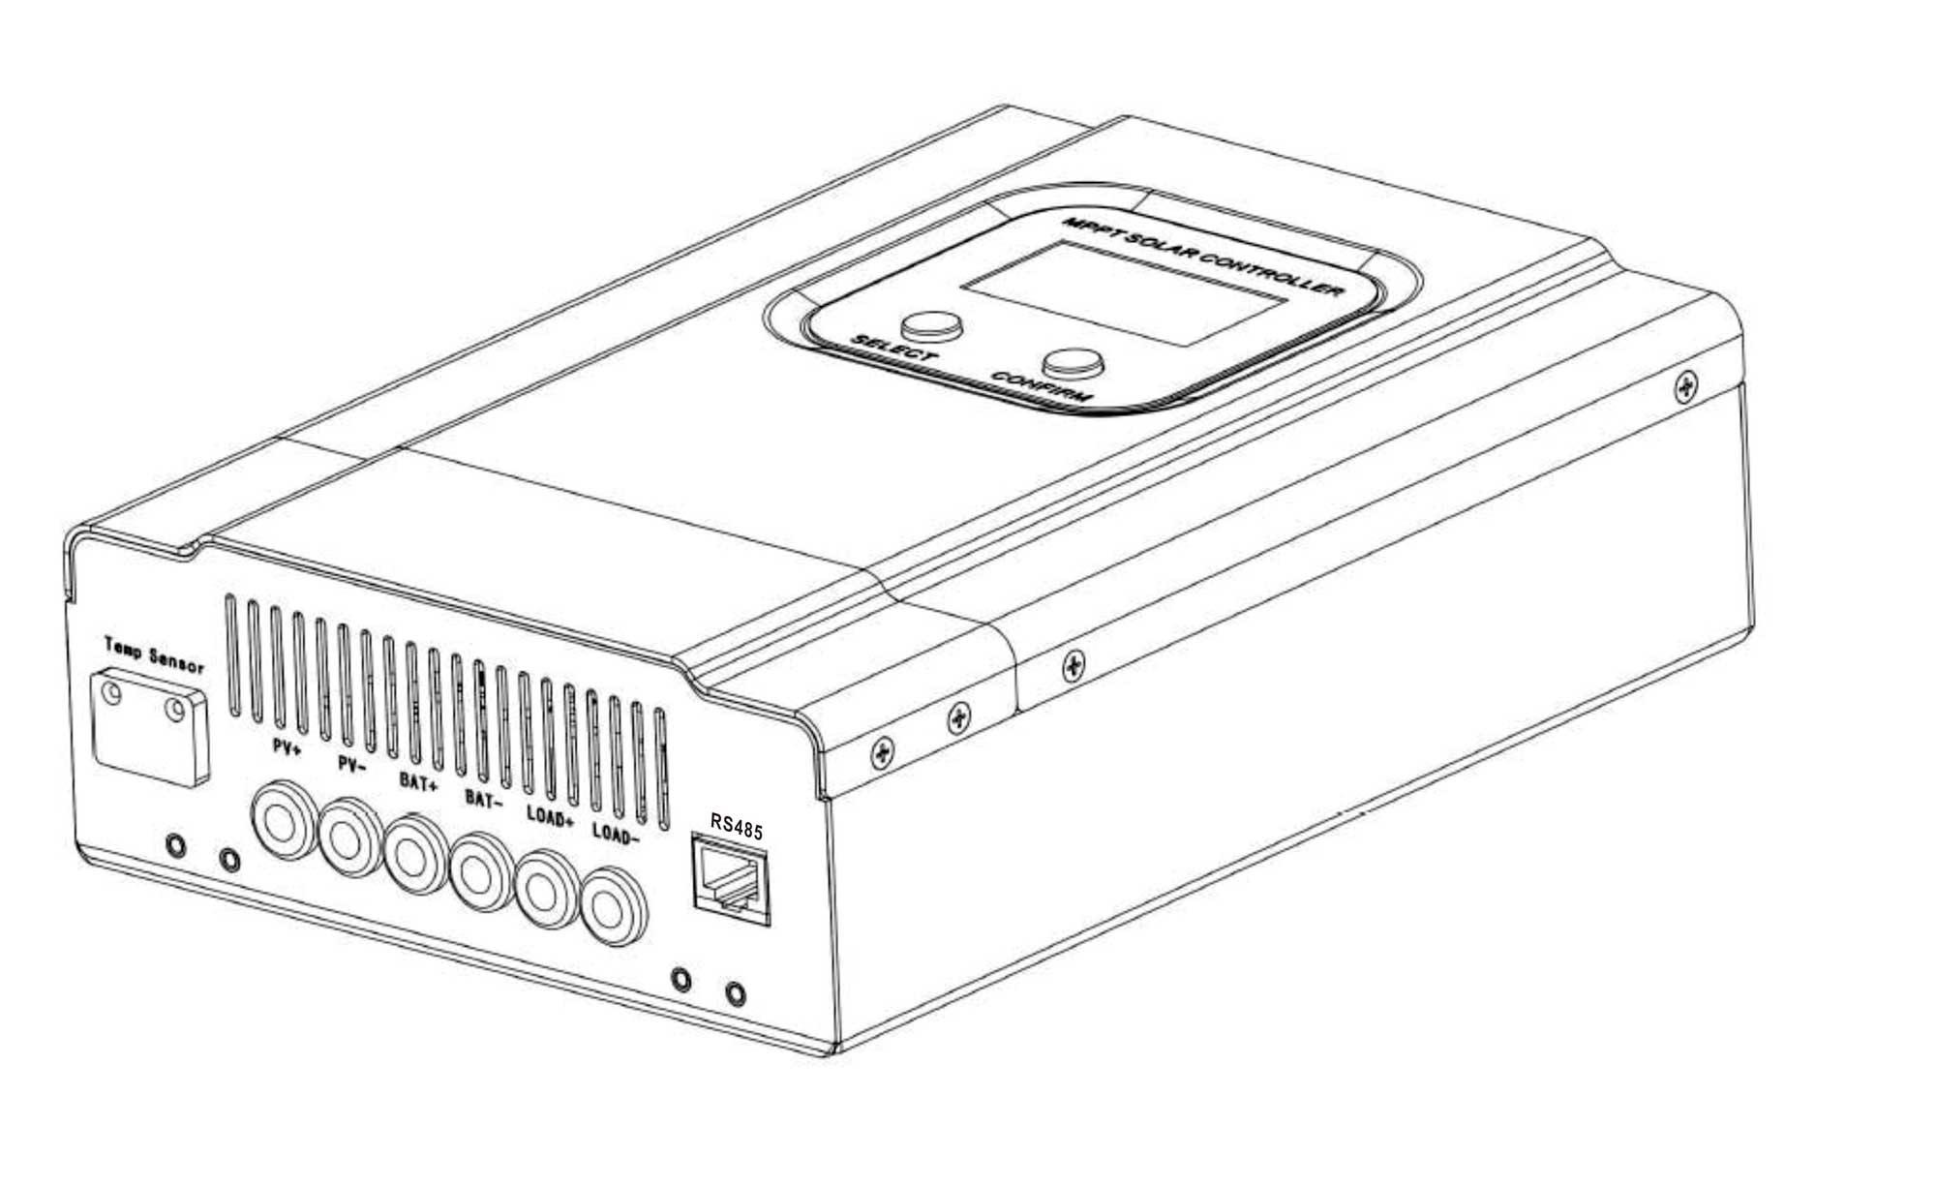

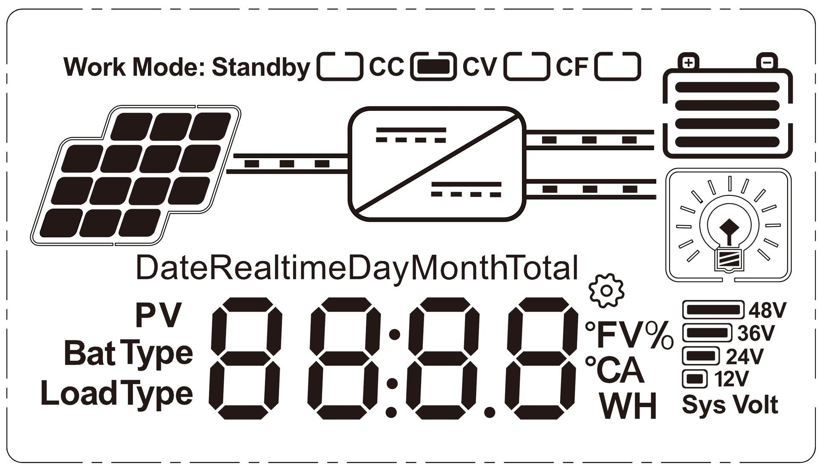
LCD display:

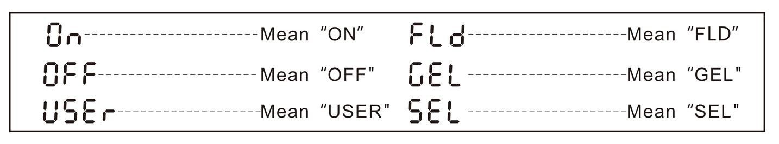
As follow is MPPT controller’s LCD digital tube display number corresponding meaning.

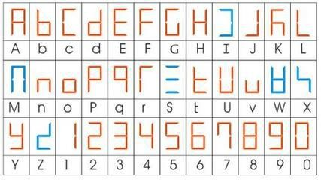
In order to check clearly, as follow is the digital tube display character and the English comparison table for reference:

Important safety instructions (for the convenience of future use, please keep this handbook. Please read all the instructions and notes in the manual carefully before you install it).

This manual contains all the safety, installation and operation instructions of the series solar charge controller (hereinafter referred to as "controller"):

Please install it in the room to avoid the exposure of the components and prevent the water from entering the controller.

Install the controller in well ventilated places, the controller’s case temperature may become very hot during operation.

It is recommended that safety or circuit breakers be connected to the input, load and battery terminals to prevent the danger of electric shock in use.

After installation, check all connections are firm, to avoid the false connection caused by heat accumulation and dangerous.

If the display is not displayed for the first time, please cut off the fuse or circuit breaker immediately and check whether the line is connected correctly.

If the system needs to connect the inverter, please connect the inverter directly to the battery, and do not connect with the load end of the controller.

When the controller is in the normal charge state, do not disconnect the battery connection, otherwise the DC load may be damaged.

Catalog
- MPPT Controller General Information 4
  - Overview 5
  - Characteristics 6
  - Accessories Instruction 6
  - Maximum Power Point Tracking Technology 7
  - Battery Charging Stage 8
- Installation Instructions 9
  - Selecting the Mounting Location 9
  - Safe distance 9
  - Dimensions and Weight 10
  - Precautions for controller installation 10
- MPPT Controller Connection 10
  - Connection of the PV Power System 10
  - Serial connection (string) of PV modules 10
  - PV Array Input Total Power 11
  - System Voltage and Battery Type 11
  - DC Load Output Voltage and Max. Discharge Current 12
  - Specifications for Cables and Breakers 12
  - Steps of Switch on and off 13
  - Communication port description 14
- Operation 14
  - Button Function 14
  - LCD Display 14
- Parameters 17
- maintenance and cleaning 18
  - replacement fuse 18
  - clean air vent radiator 18
- warranty 18
- Warranty card 18

MPPT Controller General Information

Overview

Thank you for choosing the MPPT solar charging controller!
The series has high conversion efficiency, soft LCD backlight display, efficient MPPT algorithm, neat internal structure and beautiful appearance design. With the continuous optimization of the products, the series has its unique advantages:
- The various sampling data show on the screen, convenient user access.
- The PV input voltage range up to 150V, suitable for various specifications of solar panels.
- The power supply uses ultra low power chip, reducing static standby power consumption, reduce energy loss.
- Continuous optimization design, super high cost performance.

Features:
- It has an efficient MPPT algorithm, MPPT efficiency ≥99.5%，and converter efficiency up to 98%
- Charge mode: three stages (constant current, constant voltage, floating charge), it prolongs service life of the batteries.
- Four types of load mode selection: ON/OFF, PV voltage control, Dual Time control, PV+Time control .
- Battery system voltage automatic recognition.
- Three kinds of commonly used lead-acid battery (Seal\Gel\Flooded) parameter settings fcan be selected by the user, and the user can also customize the parameters for other battery charging.
- It has a current limiting charging function. When the power of PV is too large, the controller automatically keeps the charging power, and the charging current will not exceed the rated value.
- High definition LCD display function to check the device running data and working status, also can support modify the controller display parameter.
- RS485 communication, we can offer communication protocol to convenient user’s integrated management and secondary development.
- Support PC software monitoring and WiFi module to realize APP cloud monitoring.
- CE, RoHS, FCC certifications approved, we can assist clients to pass various certifications.
- 3 years warranty, and 3~10 years extended warranty service also can be provided.

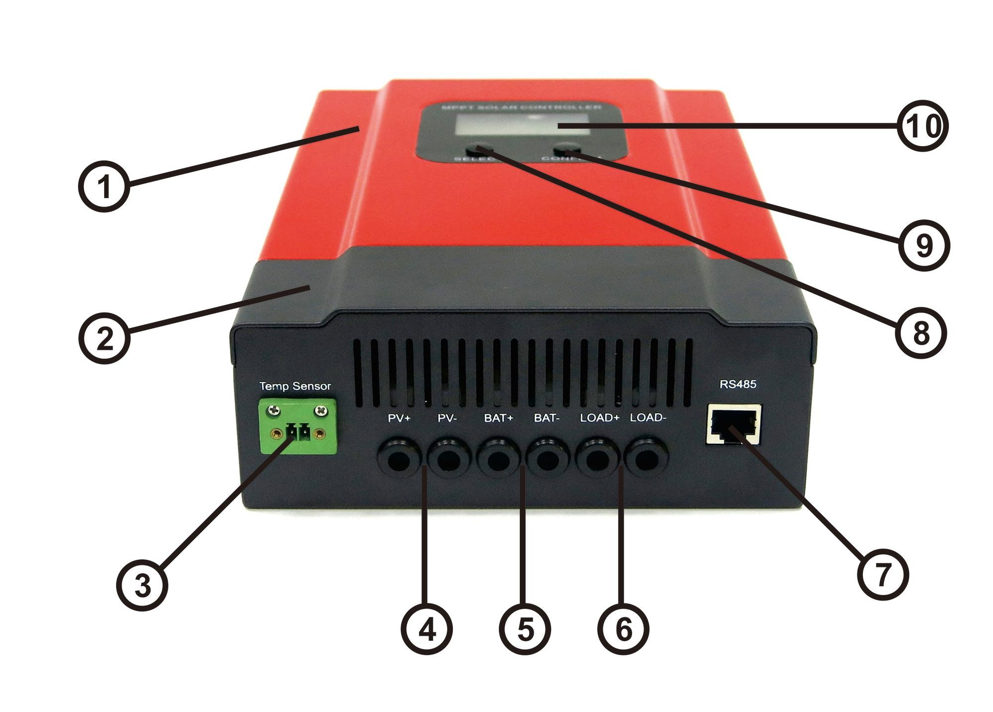
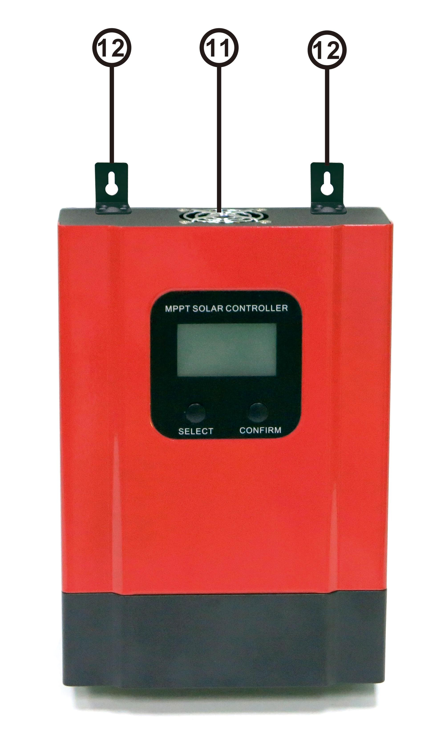
Characteristics

Item | Name | Item | Name
① | Case | ⑦ | RS485 port/WIFI port
② | Terminal Cover | ⑧ | Select Button
③ | Bat. Temp Sensor | ⑨ | Confirm Button
④ | PV Terminals | ⑩ | LCD Display
⑤ | Battery Terminals | ⑪ | Fan channel
⑥ | Load Terminals | ⑫ | Hang Bracket

Accessories Instruction

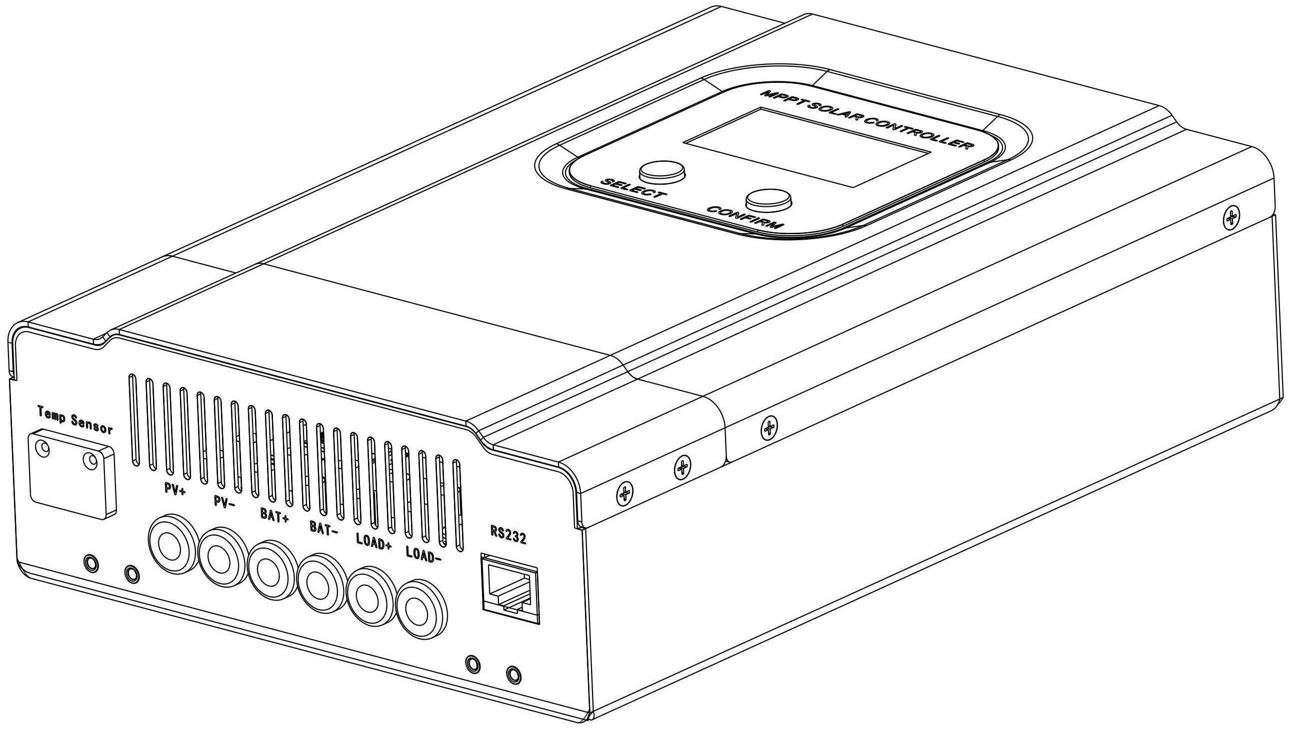
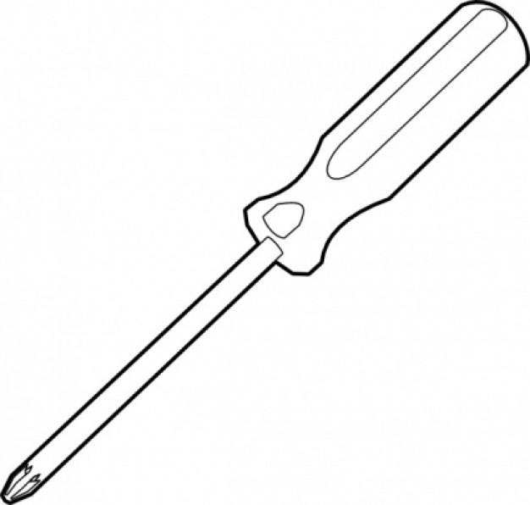
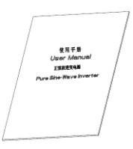
    - C E
    - D F(Optional)
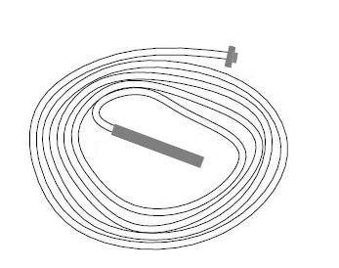

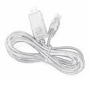
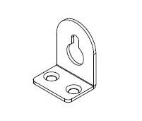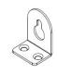MPPT Solar Charge Controller Accessories Diagram

Remark:Extra accessories can be purchased 1.RS485 to USB cable;

RS485 to wifi modular

Object | Quantity | Description
A | 1 unit | MPPT solar charge Controller
B | 2 pcs | Hang Bracket
C | 1 pcs | User Manual
D | 1 pcs | Temperature sensing wire
E | 1 pcs | Screwdriver
F | 1 pcs(Optional) | RS485 to USB cable

If there is any part missing, please contact your dealer.

Maximum Power Point Tracking Technology

The MPPT controller can detect the generation voltage of the solar panel in real time and track the maximum voltage and current value (V-I), so that the system can charge the battery with the maximum power output.
Under the assumption that the conversion efficiency of the system is 100%, the following formula is established.
Input Voltage(VMpp)* Input Current (IPV)=Battery Voltage (VBat)*Charge Current (IBat)

Normally, the VMpp is always higher than VBat, Due to the principle of conservation of energy, the IBat is always higher than IPV. The greater the discrepancy between VMpp &VBat, the greater the discrepancy between IPV&IBat. The greater the discrepancy between array and battery. This is also the simplest way to distinguish whether the real MPPT controller.
As the Figure shown below, is the maximum power point curve, the shadow is the working range of the PWM controller, it can obviously diagnose that the MPPT mode can improve the usage of the solar energy resource. According to our test, our company's MPPT controller can improve the utilization of solar array 20%~60% ( The efficiency may be dirfferent due to the environment.)
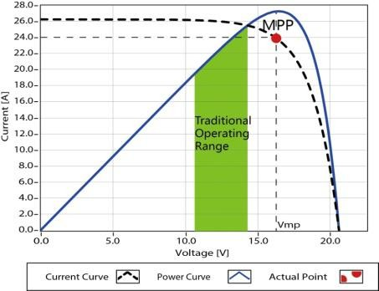
Maximum Power Point Curve

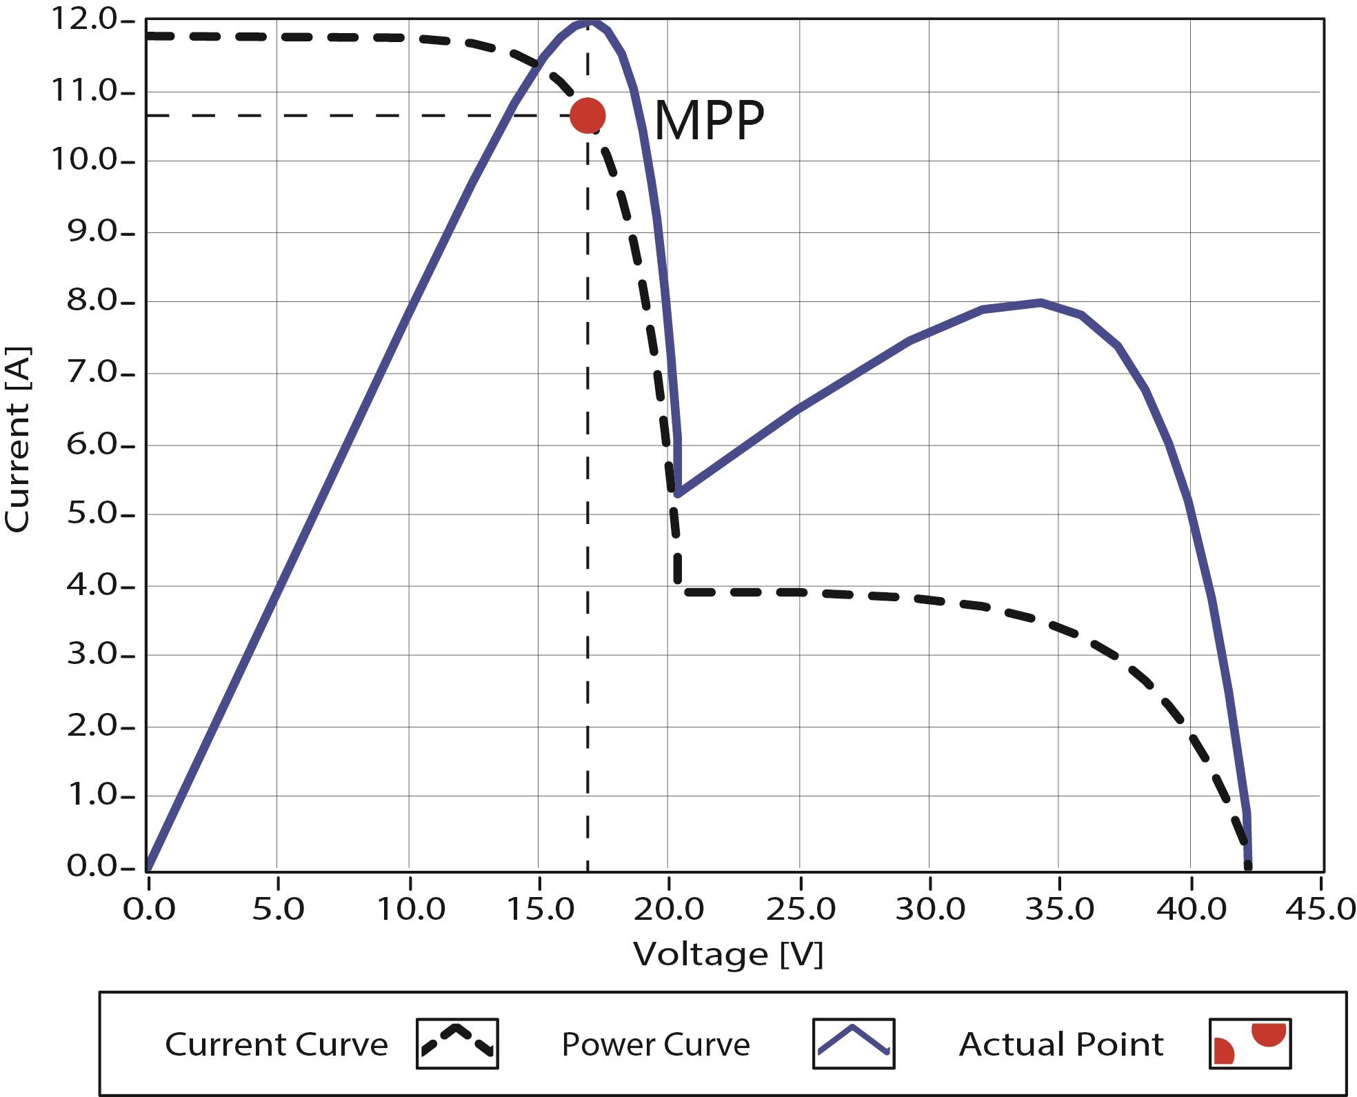
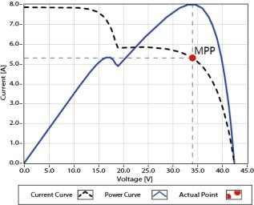
In actual application, as shading from cloud, tree and snow, the panels may have multiple MPPT points, but there is only one real Maximum Power Point. As the below Figure shows:

Mutil-MPP Curve
If there are multiple MPPT points, if there is no good algorithm, it will lead to work on the unreal MPPT point. Our product can track the actual MPPT point quickly and accurately, improve the utilization of array energy and avoid the waste of resources.

Battery Charging Stage

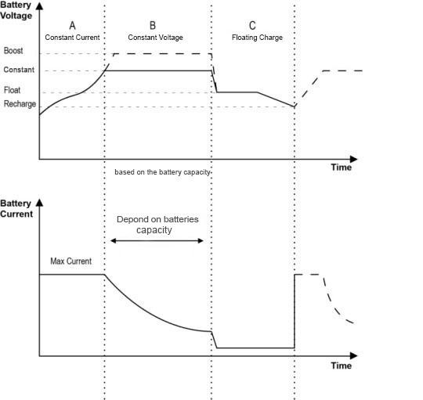
The controller have 3 stages charge mode, Constant Current Charging(Bulk Charging), Constant Voltage Charging(CV) and Floating Charging(CF) for rapid, efficient, and safe battery charging.

Battery Changing Stage Curve

Constant Current Charging_CC(Bulk Charging)
In this stage, the battery voltage has not yet reached constant voltage (Constant or Boost Voltage), the controller operates in constant current mode, delivering its maximum current to the batteries (MPPT Charging).

Constant Voltage Charging_CV( Constant and Boost Charging)
When the battery voltage reaches the constant voltage set point, the controller will start to operate in constant voltage charging mode, this process the charging current will drop gradually. The constant charge voltage will increase 0.2V on the basis of constant voltage at 1st of each month, charge time is 60 mins. ( The data of boost charge voltage can be set via PC software and APP)

Floating Charging_CF
After the constant voltage stage, the controller will reduce charging current to maintaining the battery voltage on the Floating Voltage set point. Charging the battery with a smaller current and voltage on Floating Voltage stage, while maintaining full battery storage capacity.
In Floating charging stage, loads are able to obtain almost all power from solar panel.If loads exceed the power, the controller will no longer be able to maintain battery voltage in Floating charging stage. If the battery voltage remains below the Recharge Voltage, the system will leave Floating charging stage and return to Bulk charging stage.

Installation Instructions

Selecting the Mounting Location
 The position should be taken into consideration of the weight and size of the controller.
 The ambient temperature of the position should be within the range of -20℃ ~50℃.
 A good ventilation environment should be maintained in the position.
 Install position should avoid direct sunlight.

Safe distance
Refer to the following safety clearance to ensure that other equipment or objects are not within this range to ensure that there is sufficient space for heat dissipation.
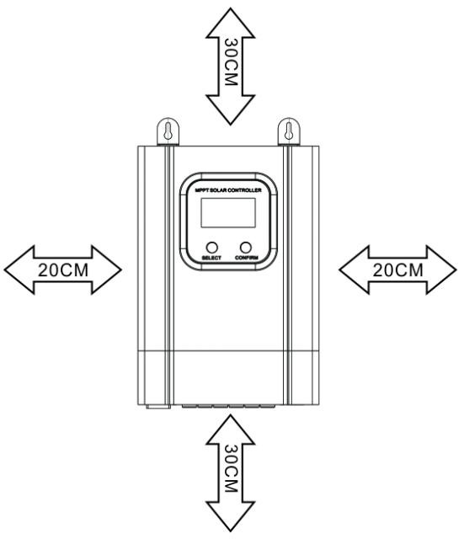
Direction | Safety Distance
Left-Right direction | >20cm
Up-Down direction | >30cm

Controller Safety Distance

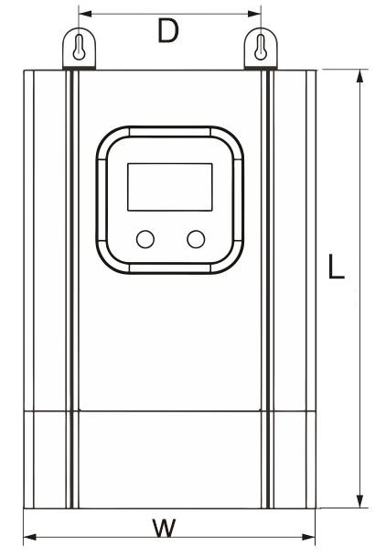
Dimensions and Weight

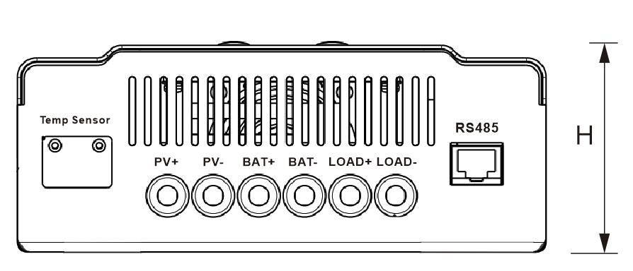

(Unit: MM)

Product model | L | W | H | D | Net Weight
20A/30A/40A | 240 | 168 | 66 | 112 | 2.3kg
50A/60A | 270 | 180 | 85 | 112 | 2.6kg

Precautions for controller installation

Please read the safety instructions of the title page carefully before installing the controller！

MPPT Controller Connection

Connection of the PV Power System

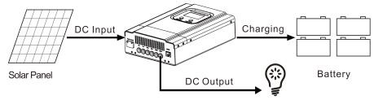

PV Power System Connection Diagram

Serial connection (string) of PV modules

As the core component of PV system, controller could be suitable for various types of PV modules and maximize converting solar energy into electrical energy. According to the open circuit voltage(Voc ) and the maximum power point voltage(VMpp ) of the MPPT controller, the series number of different types PV modules can be calculated. The below table is for reference only.

PVinput <DC 150V Prohibit the total input voltage greater than 150V
System Voltage | 36cell Voc<23V |  |  | 48cell Voc<31V |  | 54cell Voc<34V |  | 60cell Voc<38V
 | Max. | Best |  | Max. | Best | Max. | Best | Max. | Best
12V | 6 | 2 |  | 4 | 1 | 4 | 1 | 3 | 1
24V | 6 | 3 |  | 4 | 2 | 4 | 2 | 3 | 2
36V | 6 | 4 |  | 4 | 3 | 4 | 3 | 3 | 3
48V | 6 | 5 |  | 4 | 4 | 4 | 3 | 3 | 3
PVinput <DC 150V Prohibit the total input voltage greater than 150V
System Voltage | 72cell Voc<46V |  | 96cell Voc<62V |  |  | Thin-Fim Module 80V<Voc<150V
 | Max. | Best | Max. |  | Best | Max. |  | Best
12V | 3 | 1 | 2 |  | 1 | 1 |  | 1
24V | 3 | 2 | 2 |  | 1 | 1 |  | 1
36V | 3 | 2 | 2 |  | 1 | 1 |  | 1
48V | 3 | 2 | 2 |  | 2 | 1 |  | 1
NOTE: The above parameter values are calculated under standard test conditions (STC (Standard Test Condition): Irradiance 1000W/m2, Module Temperature 25℃, Air Mass 1.5)

PV Array Input Total Power

This MPPT controller has a limiting function of charging current, the charging current will be limited within rated range. Therefore, the controller will charge the battery with the rated charging power even if the input power at the PV exceeds. Such as: for 12V Solar System with 30A controller, no matter the input power of the solar panel is greater than the rated number, the charging current will not be more than 30A.
The actual operation power of the PV array conforms to the conditions below
- PV power ≤ controller rated power, the maximum power of the controller is equal to the actual power of the PV array.
- PV power > controller rated power, the maximum charge power of the controller is equal to the rated power. If the PV array higher than rated power, the charging time at rated power to battery will be longer, more energy to battery yields. Meanwhile, it will waste the power under the fierce sunshine due to the limitation of current.
Note: for the rated power of different types of products, please refer to the technical parameters form.

System Voltage and Battery Type

1) The controller can charge the DC12V, DC24V, DC36V and DC48V batteries. The controller recognised the system according to the voltage of the first connected battery and reidentified after the power failure was restarted. Therefore, please confirm whether the LCD display system is consistent with the actual system when starting, otherwise, it is necessary to recheck the battery voltage.
Note:battery group detailed system identification voltage please refer to the technical parameters table! 2）The controller has been set up to charge 3 kinds of conventional battery parameters for the following
forms. If you need to charge for other special batteries, please choose "User" type, then set up by PC software or APP. (parameters is in 12V system at 25℃, please use double value in 24V, use three times value in 36V and use four times value in 48V.)

Battery type | Constant voltage | Floating voltage
Flooded | 14.6V | 13.8V
Sealed | 14.4V | 13.8V
Gel | 14.2V | 13.8V
User (setting) | C(9V~15V) | F(9V~15V)

DC Load Output Voltage and Max. Discharge Current

The controller has DC LOAD output function, and its output voltage range is the same as the battery group. If the battery's voltage is 48.6V, then DC can output a voltage of 48.6V at this moment.

Specifications for Cables and Breakers

The wiring and installation methods must conform to all national and local electrical code requirements.

PV array specification of Wiring
Since PV array output can vary due to the PV module size, connection method or sunlight angle, the minimum wire can be calculated by the Isc of PV array. Please refer to the value of Isc in PV module specification. (When the PV modules connect in series, the Isc is equal to the PV module's Isc. When the PV modules connect in parallels, the Isc is equal to the sum of PV module's Isc. )
And in order to facilitate the opening and closing of the machine and safety, it is recommended to install the circuit breaker. Please refer to the specification selection of the next table wire and circuit breaker.

Model | Rated charge current | Rated discharge current | Battery wire (mm2/AWG) | Load wire (mm2/AWG) | Breaker
20A | 20A | 40A | 4/10 | 14/7 | >40A
30A | 30A | 40A | 8/8 | 14/7 | >50A
40A | 40A | 40A | 14/7 | 14/7 | >63A
50A | 50A | 60A | 16/6 | 20/5 | >100A
60A | 60A | 60A | 20/5 | 20/5 | >100A

Before you connect the wire, please open the product case. After done it, please close and locked them, it is helpful to protect the connection port.

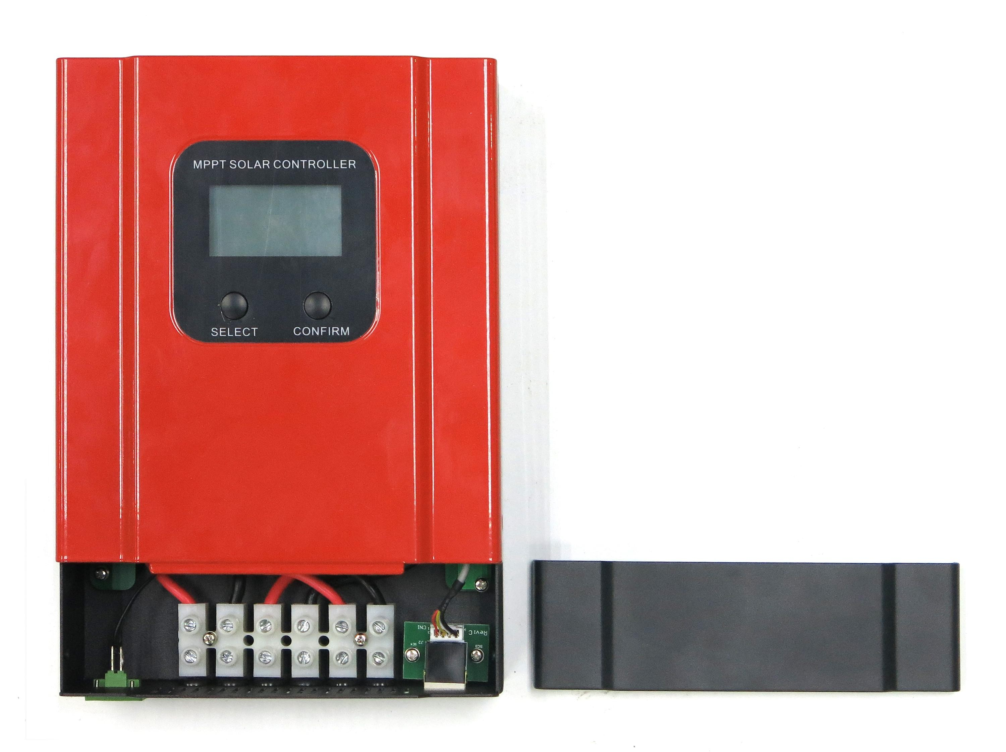

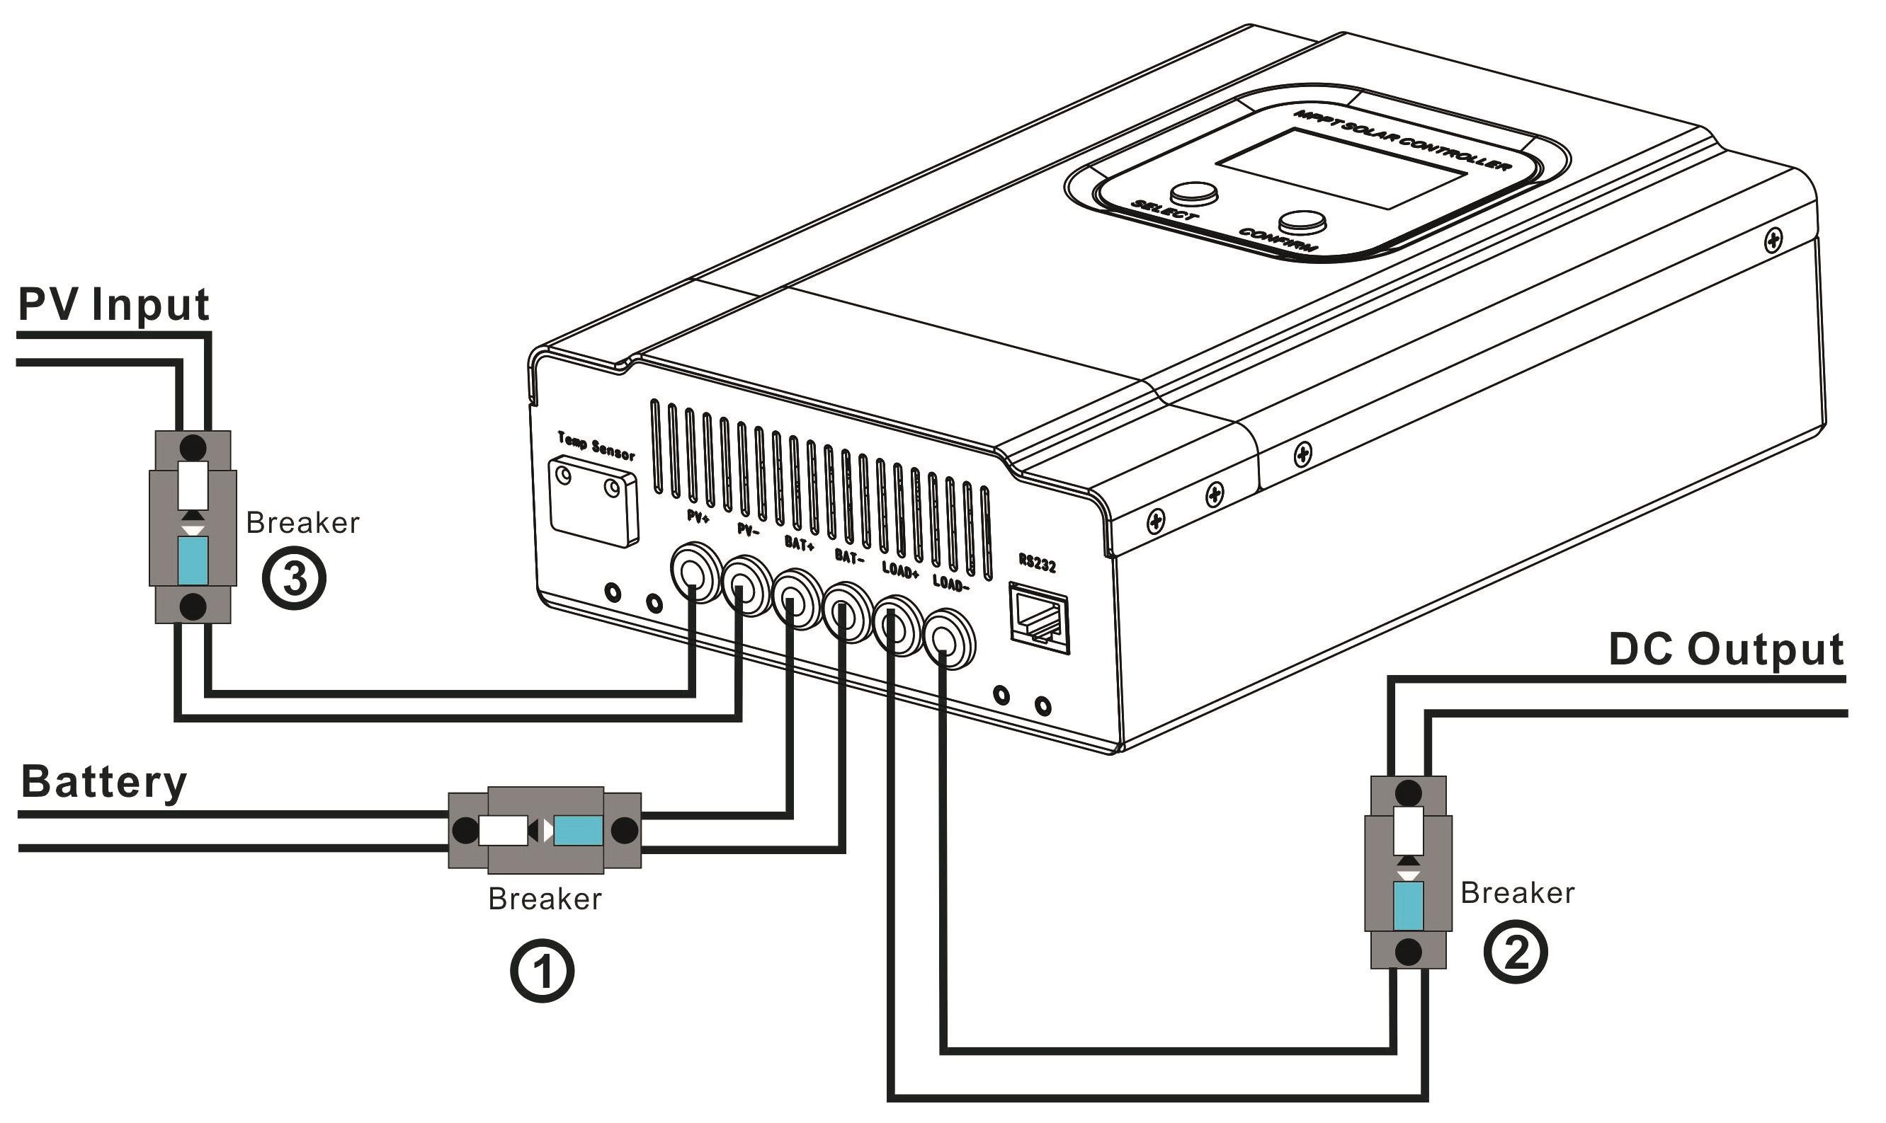
Steps of Switch on and off

Make sure that the controller is installed and connected as above
Opening process: Step 1: open the circuit breaker on the battery side(breaker①), make sure that the controller is connected with the battery (the LCD of the controller will display the content), and set the battery type.
Step 2: if you need to use the DC load output, then set the output control mode first, and then open the DC output circuit breaker(breaker②).
Step 3: open the circuit breaker on the input side of the solar panel PV(breaker ③), if the PV input voltage is in the charge range of the controller, then the controller will enter the charging state.
Closing process: turn off the circuit breaker in turn：③②①
Warning：
- If the system needs to connect the inverter, please connect the inverter directly to the battery, and do not connect with the load end of the controller.
- When the controller is in the normal charge state, do not disconnect the battery connection, otherwise the DC load may be damaged.Therefore, the damage to the controller will not be within the warranty.

Communication port description

The communication port of the controller can match our RS485-USB communication line to achieve PC terminal monitoring software communication. It can also match our WIFI module products to achieve remote APP cloud monitoring.
The communication port is the standard 8 line RJ45 interface, and the pin is defined as follows:

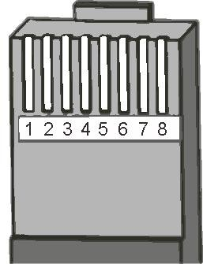
PIN | Function
1 | RS485-A
2 | RS485-B
3 | Empty
4 | Empty
5 | GND
6 | GND
7 | +5V
8 | +5V

(Note: the definition of the foot is only applicable to the related products of our company!)

Operation

Button Function

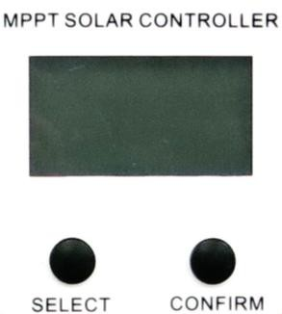 | Mode | Remark
 | Browse mode | The light press “ SELECT ” button can be viewed sequentially, and the “ CONFIRM “ button can be viewed in reverse order
 | Setting mode | When the display interface has the " identity, it  shows that it is possible to set up the operation. Press the " CONFIRM " button 3S to enter the setting mode, press the short “SELECT ” button to set the parameters, confirm the settings by short pressing the “ CONFIRM “ button, if the time greater than 10S does not operate, it will automatically exit the setup interface.

LCD Display

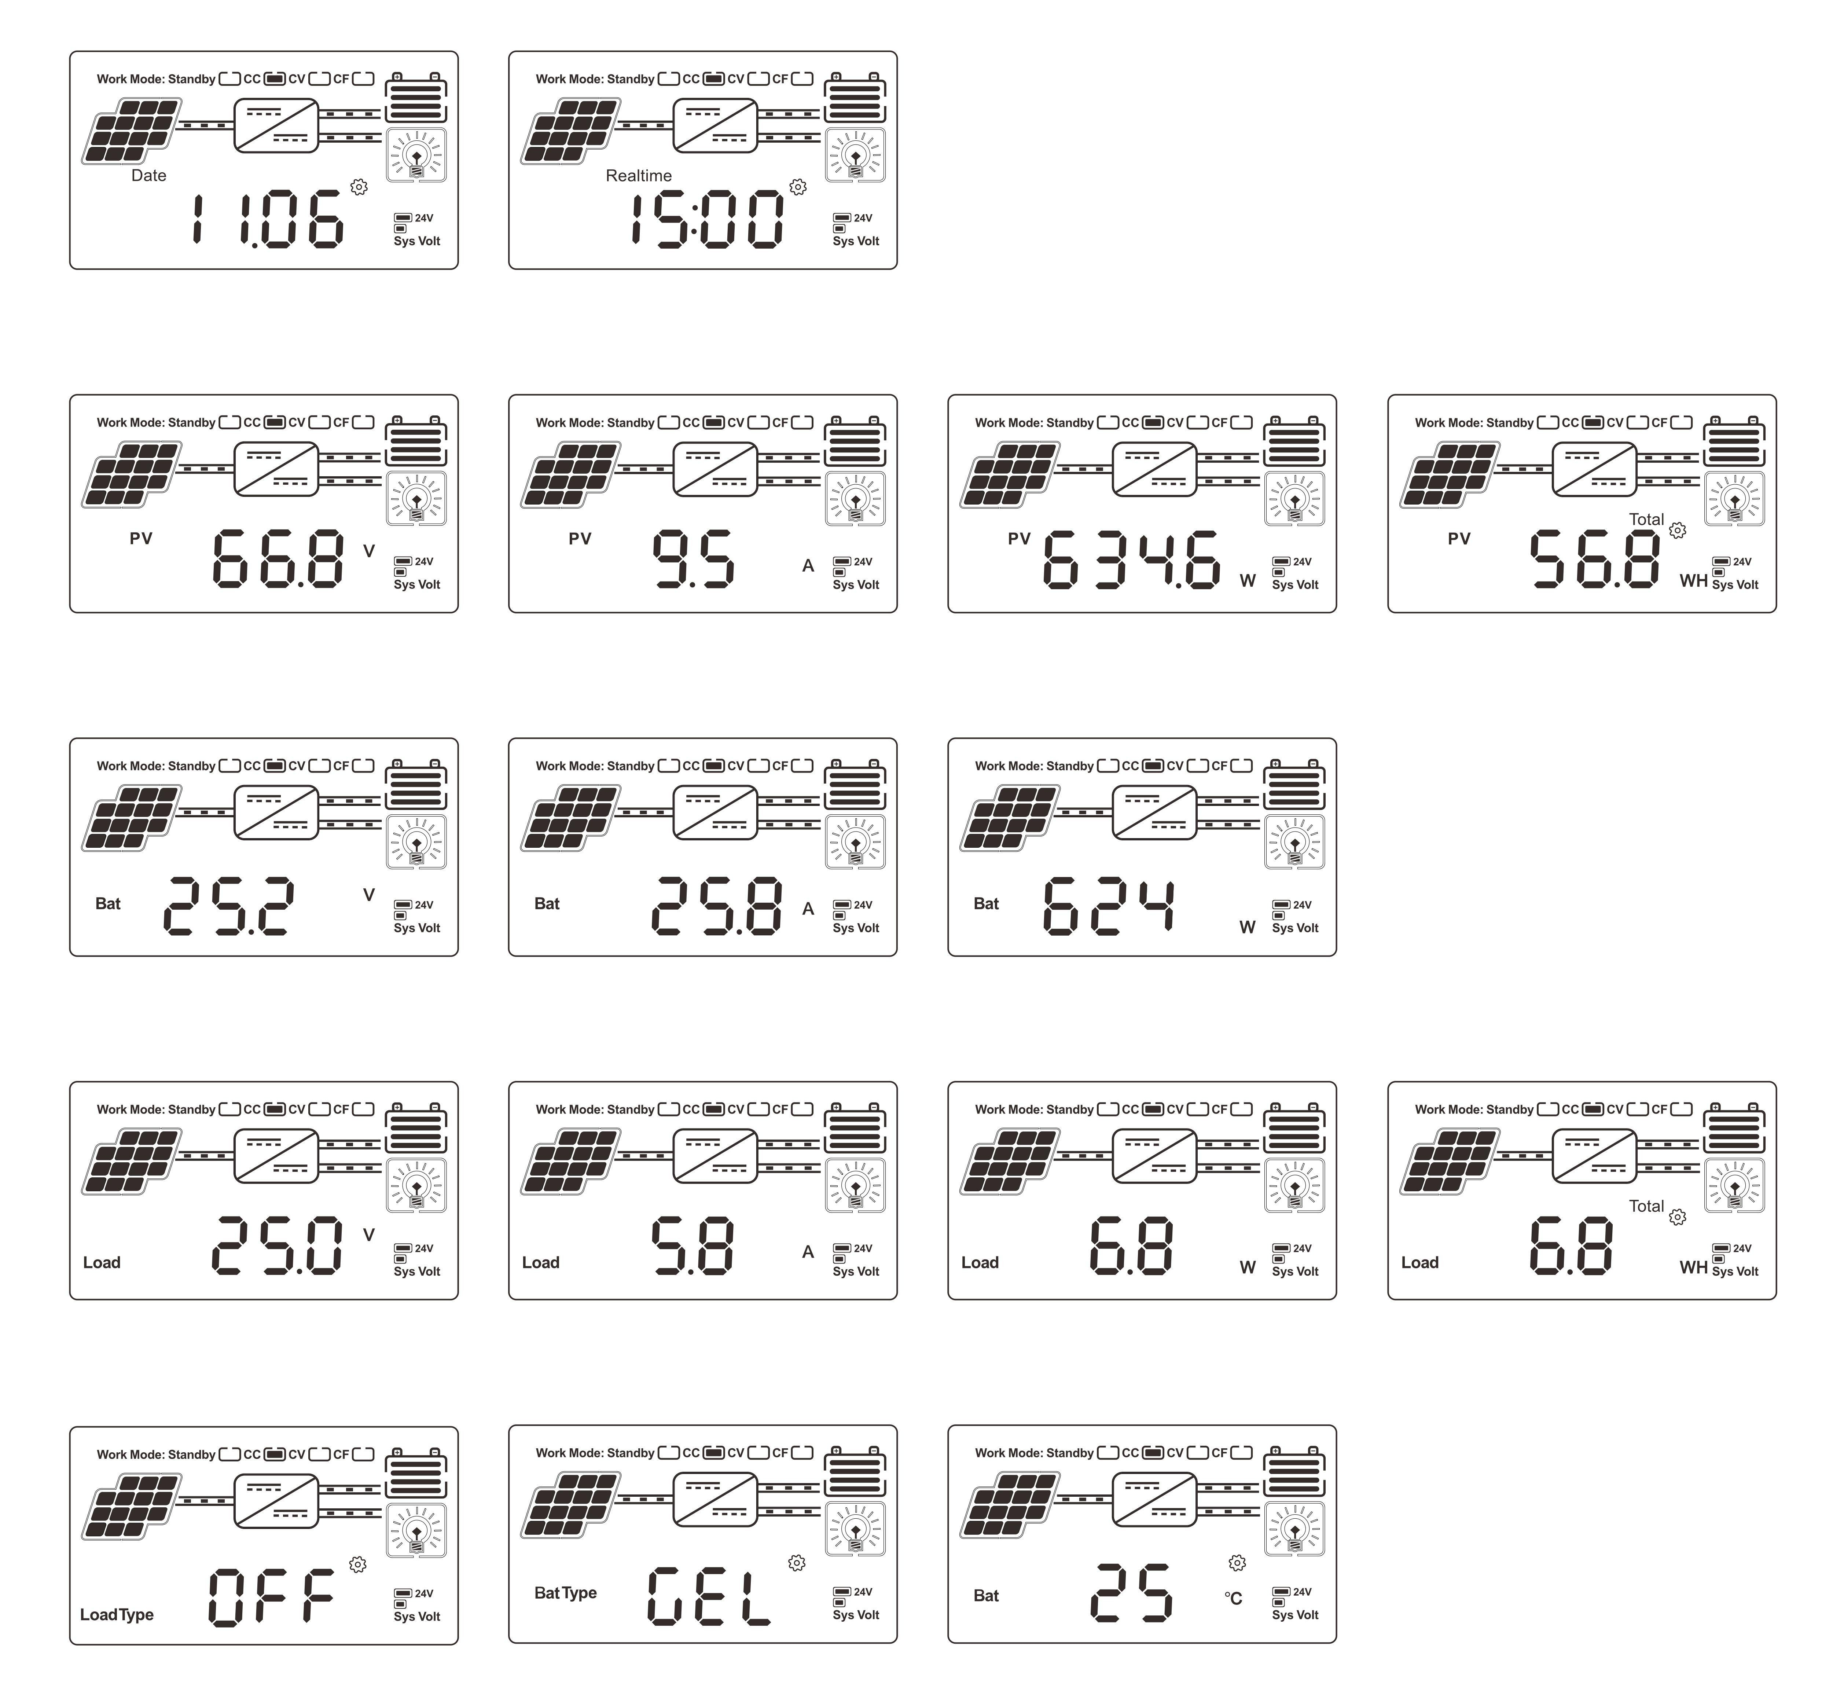
Browse Interface

Setting Interface
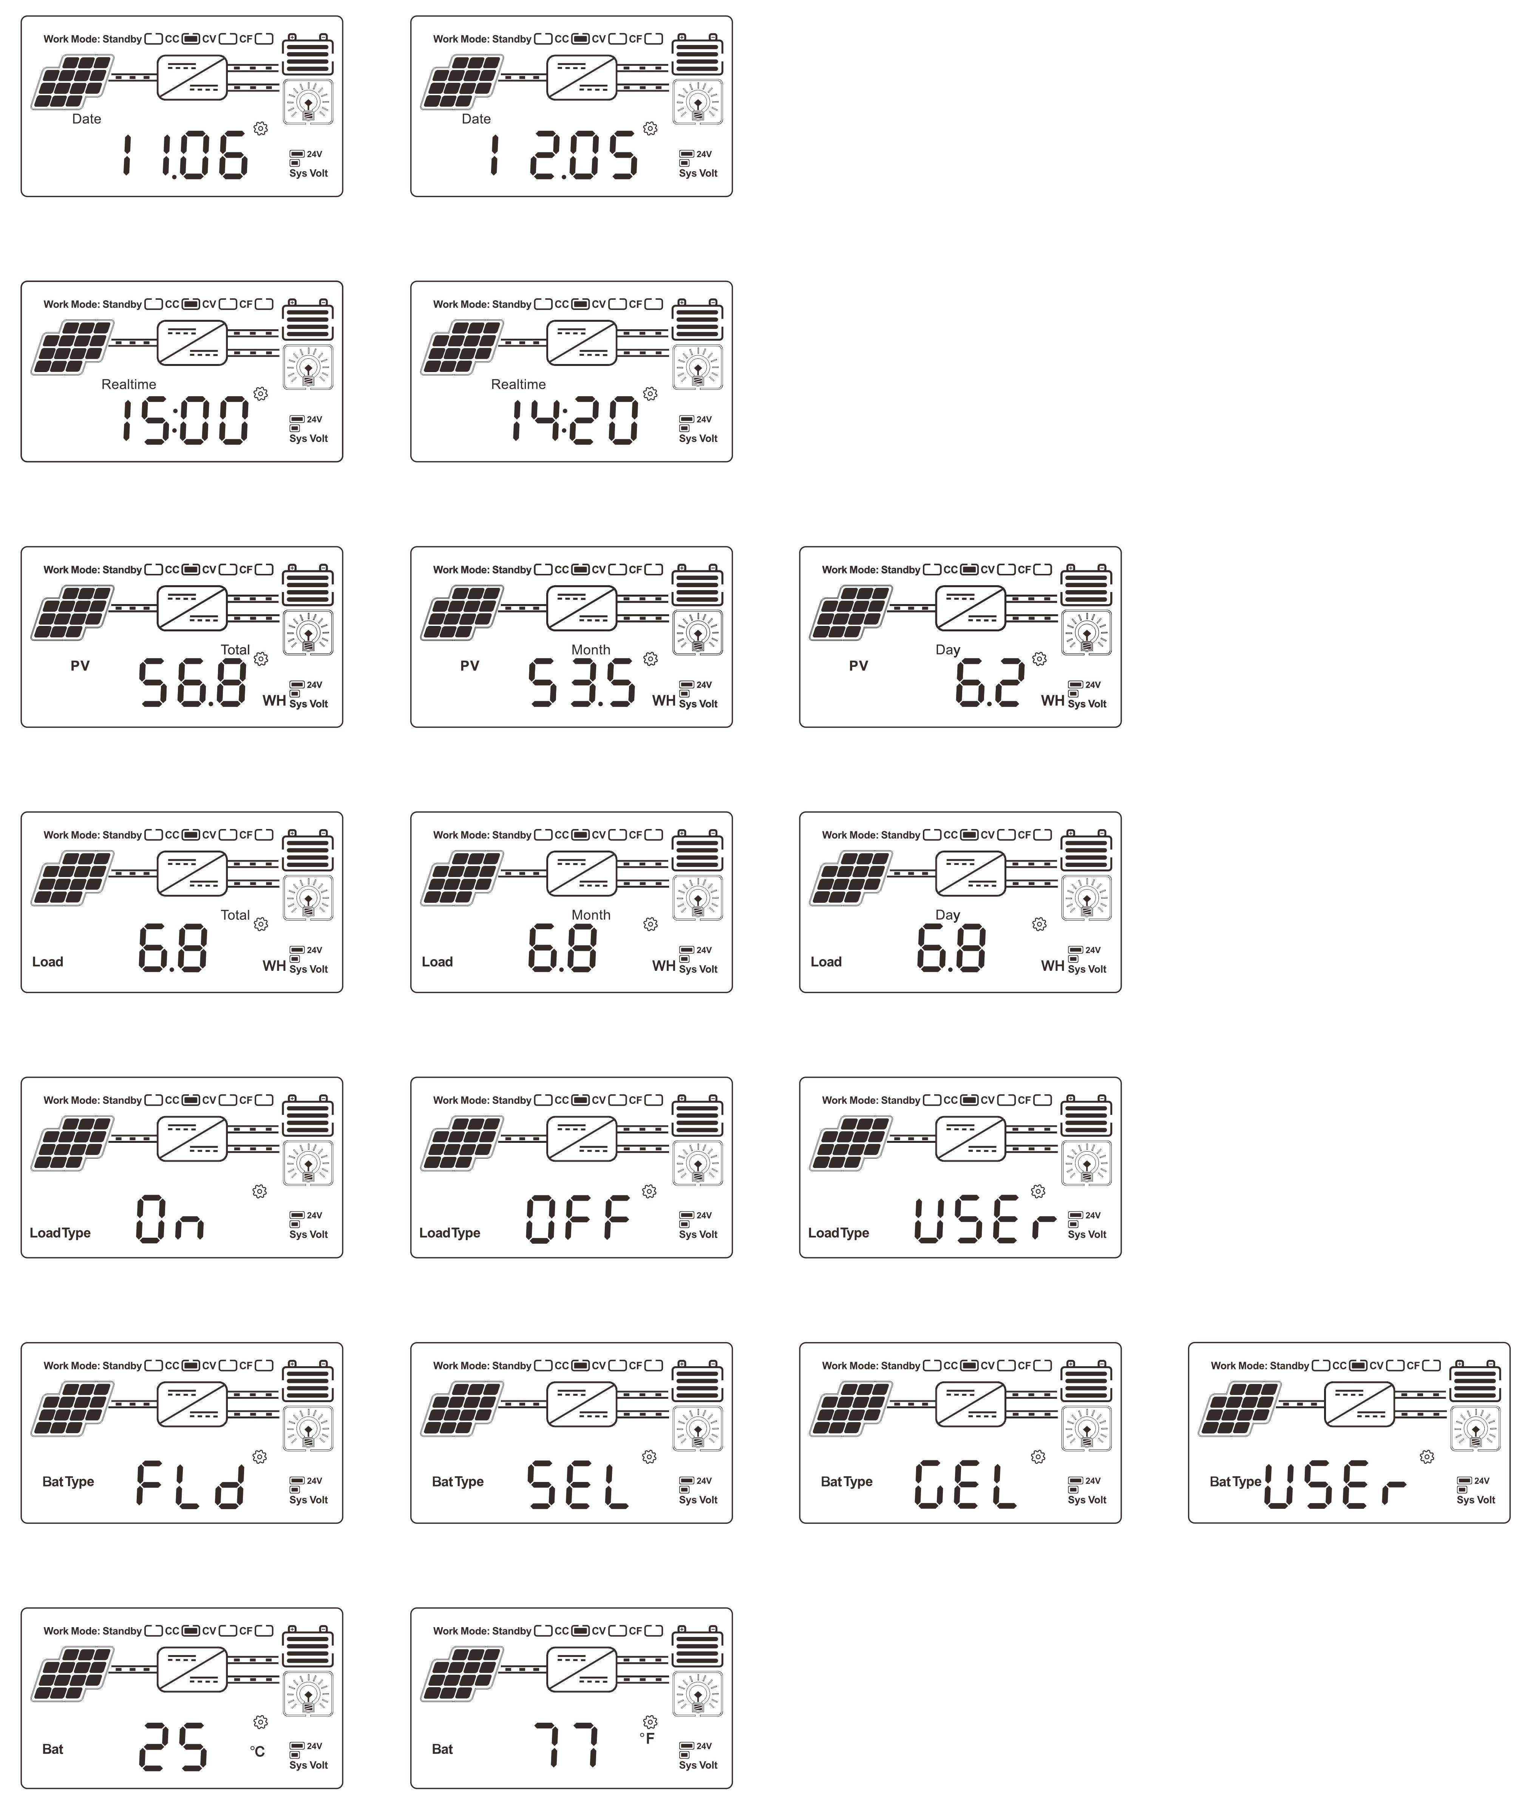
(Remark: please refer to the set mode description of the key operation in the 4.1 chapter)

On the controller, users can set date and time, set up to display daily, monthly or total power generation and electricity consumption, load switch mode can be set, battery type can be set, temperature display unit can be set, and power generation can be cleared. (Note: it is suggested that the parameters be set in the state of stopping charging in order to avoid breakdown).

Parameters

Series |  |  |  | 20A | 30A | 40A | 50A | 60A
Product category | Controller Properties |  |  | MPPT (maximum power point tracking)
 | MPPT efficiency |  |  | ≥99.5%
 | Standby power |  |  | 0.5W~1.2W
 | System voltage |  |  | Automatic recognition
 | Heat-dissipating method |  |  | Intelligent fan cooling
 | Range of system voltage identification |  | 12V system | DC9V~DC15V
 |  |  | 24V system | DC18V~DC30V
 |  |  | 36V system | DC32V~DC40V
 |  |  | 48V system | DC42V~DC60V
Input Characteristics | Max.PV input voltage(VOC) |  |  | DC150V
 | Start the charge voltage point |  |  | Battery voltage + 3V
 | Low input voltage protection point |  |  | Battery voltage + 2V
 | Over voltage protection point |  |  | DC150V
 | Over voltage recovery point |  |  | DC145V
 | Rated PV power | 12V system |  | 260W | 390W | 520W | 650W | 780W
 |  | 24V system |  | 520W | 780W | 1040W | 1300W | 1560W
 |  | 36V system |  | 780W | 1170W | 1560W | 1950W | 2340W
 |  | 48V system |  | 1040W | 1560W | 2080W | 2600W | 3120W
Charge Characteristics | Selectable Battery Types (Default Gel battery) |  |  | Sealed lead acid, Gel battery, Flooded (Other types of the batteries also can be defined)
 | Charge rated current |  |  | 20A | 30A | 40A | 50A | 60A
 | Temperature Compensation |  |  | -3mV/℃/2V (default)
 | Charge Method |  |  | 3-Stage: constant current(fast charging)-constant voltage-floating charge
 | Output Voltage Stability Precision |  |  | ≤±1.5%
LOAD  Characteristics | Load voltage |  |  | The same as the battery voltage
 | Load rated current |  |  | 40A |  |  | 60A
 | Load control mode |  |  | On\Off mode, PV voltage control mode, Dual-time control mode, PV + Time control mode
 | Low voltage protection |  |  | The default protection point is 10.5V, and it is restored to 11V (can be set)
 | Setup mode |  |  | PC software /APP/ controller display
Display & Communication | Display mode |  |  | High-definition LCD segment code backlight display
 | Communication mode |  |  | 8-pin RJ45 port/RS485/support PC software monitoring/ support WiFi module to realize APP cloud monitoring
Other Parameters | Protect function |  |  | Input-output over \ under voltage protection,  Prevention of connection reverse protection,battery shedding protection etc.
 | Operation Temperature |  |  | -20℃~+50℃
 | Storage Temperature |  |  | -40℃~+75℃
 | IP(Ingress protection) |  |  | IP21
 | Noise |  |  | ≤40dB
 | Altitude |  |  | 0~3000m
 | Max. connection size |  |  | 20mm2 |  |  | 30mm2
 | Net Weight (kg) |  |  | 2.3 |  |  | 2.6
 | Gross Weight (kg) |  |  | 3 |  |  | 3.5
 | Product Size（mm） |  |  | 240*168*66 |  |  | 270*180*85
 | Packing Size(mm) |  |  | 289*204*101 |  |  | 324*223*135
17

maintenance and cleaning

replacement fuse
If the insurance is caused by high temperature or other faults, the fuse needs to be replaced correctly. Remove the broken fuse from the interface, install the new fuse, check whether the connection is correct, and install the equipment.

clean air vent radiator
Clean the fan vent and internal heat sink regularly and wipe with dry or wet cloth.
Note: no washing liquid or corrosive solvent can be used, and liquid is not allowed to flow into the machine to ensure that the ventilation holes of the equipment are not blocked.

warranty
Within the warranty period, the controller can be repaired free of charge if it is not caused by improper operation, otherwise the cost of repair will be charged.
In the delivery of the agent, please properly package the equipment to avoid damage to the equipment in the transportation.

Warranty card


MPPT controller warranty card
Name |  | Country
Addr |  | mail
Tele-Number |  | Zip code
Date of purchase |  | Supplier
Install date |  | installation personnel
Contact information
Controller model
Solar controller sequence number
Battery pack parameters
Parameters and configuration mode of solar energy components
Remarks

18

